Practical no. 7

Layer 2 security

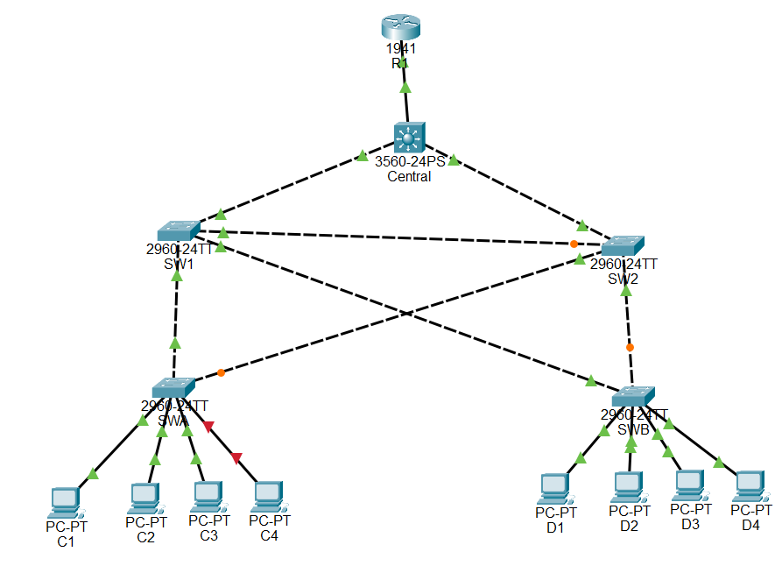

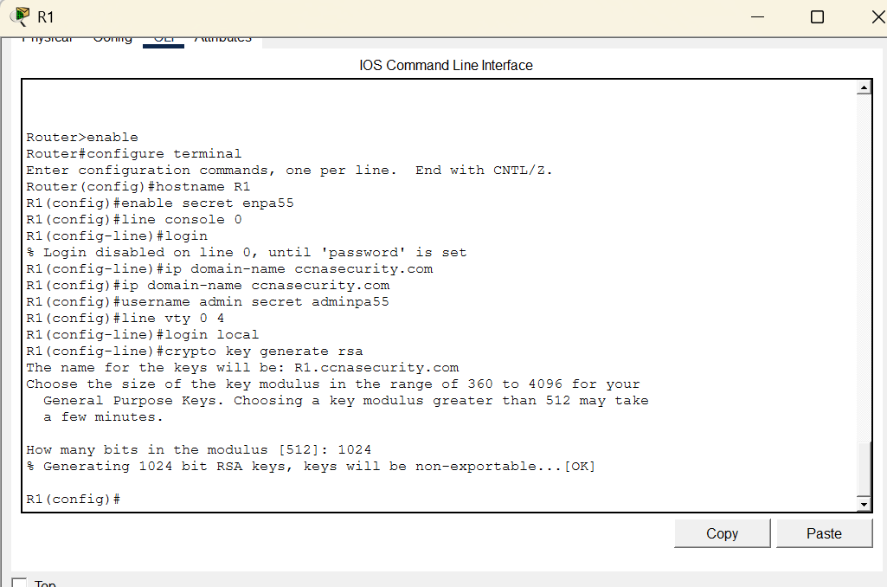

Central switch (enable ssh protol set password)
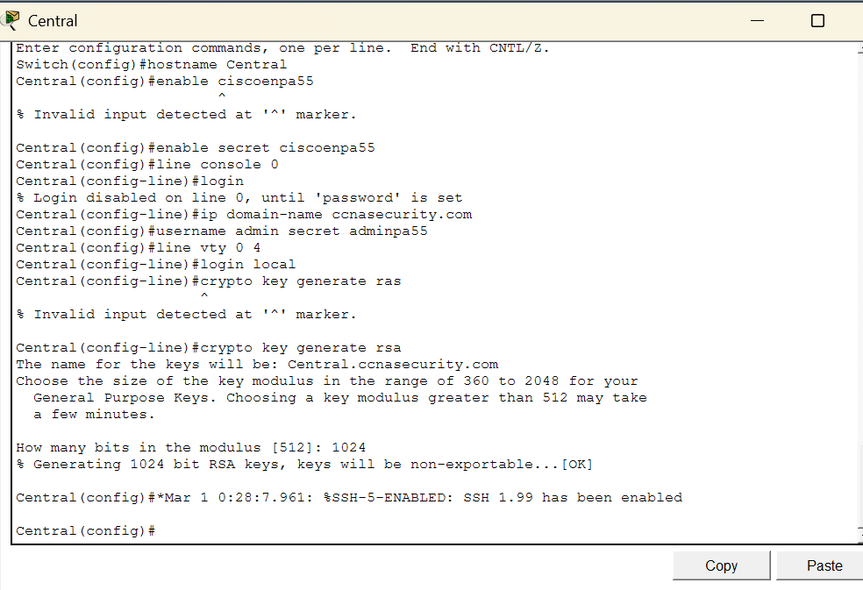
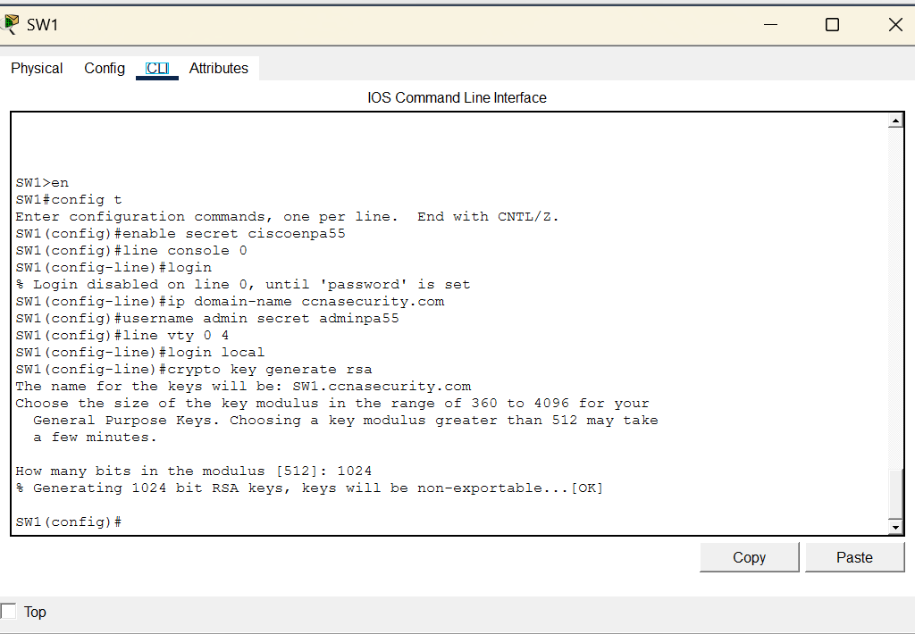

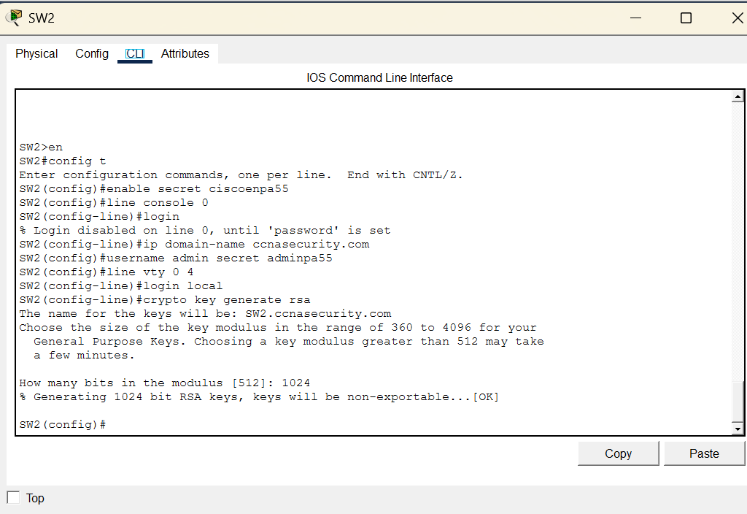

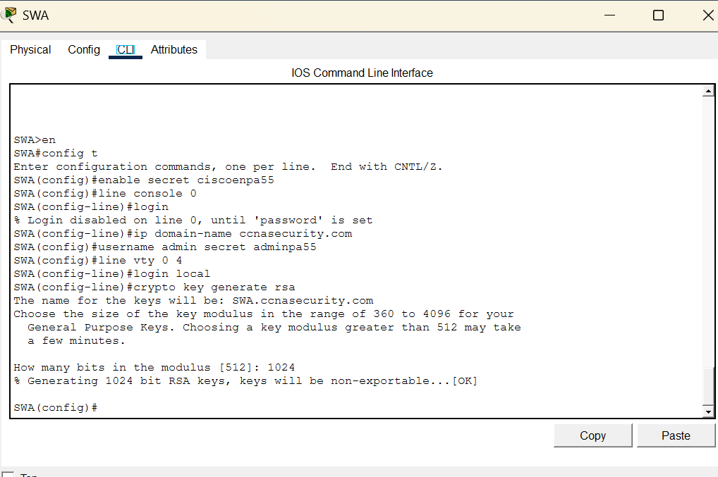

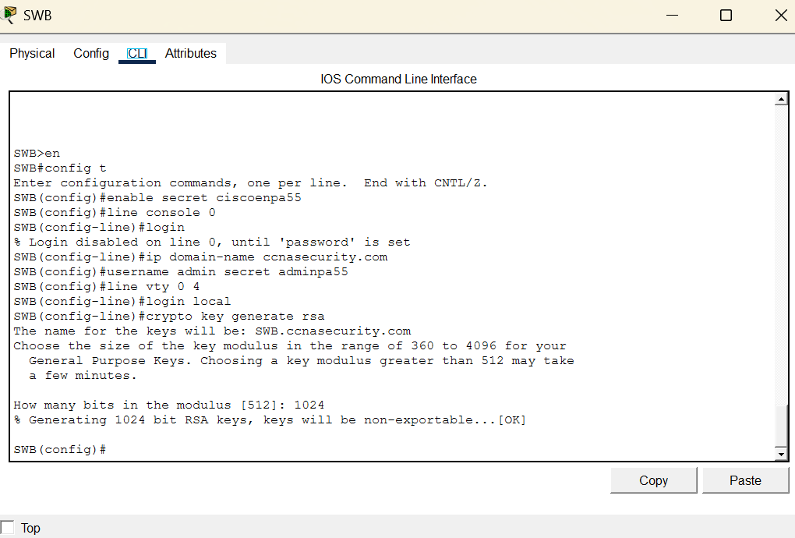

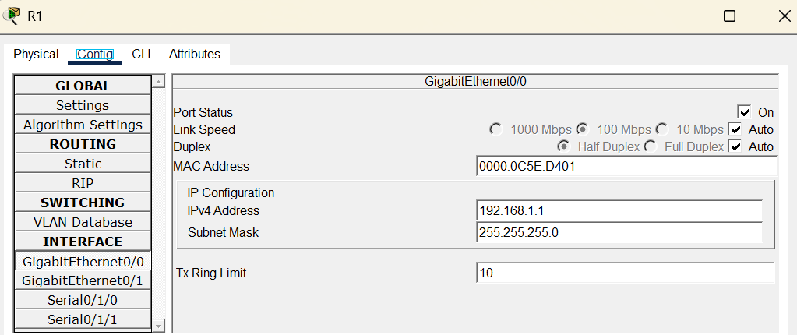

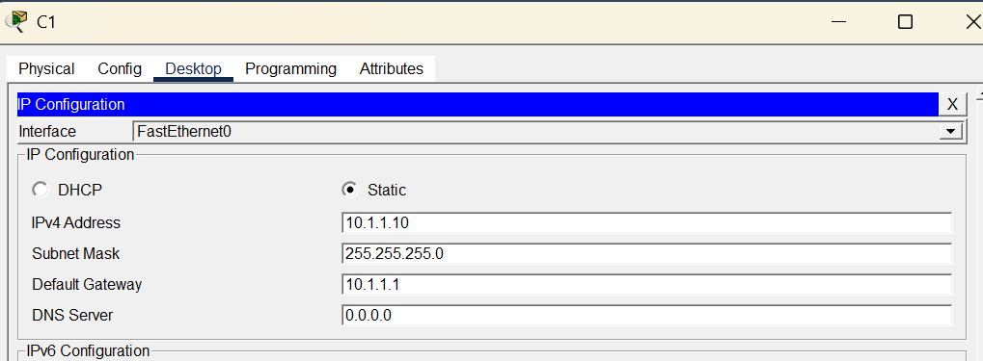

Pass is ciscoenpa55

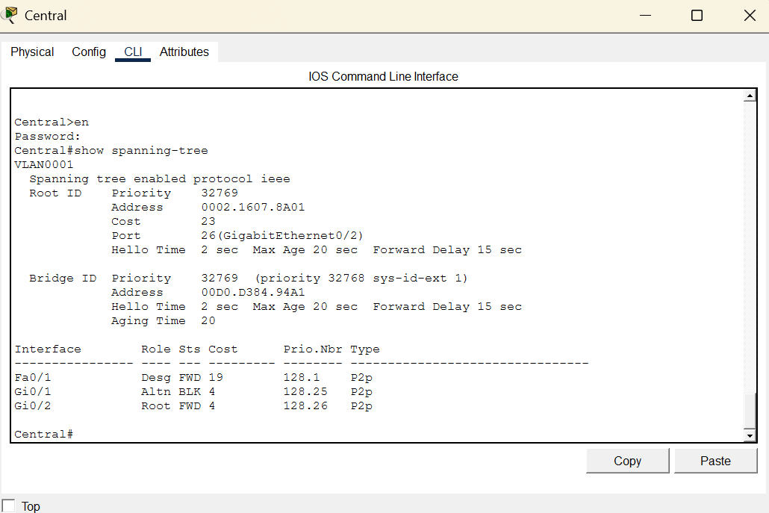
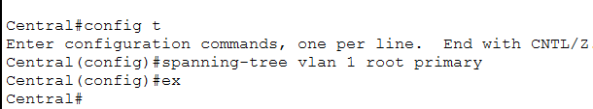

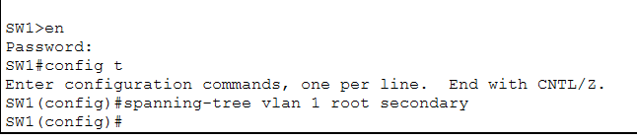

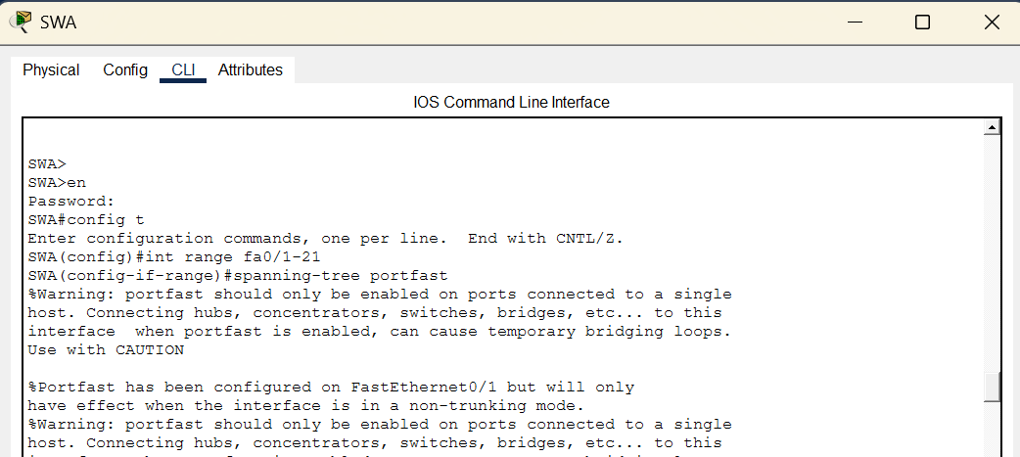

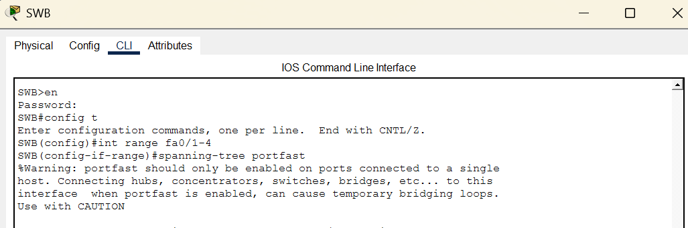

SWA(config-if-range)#spanning-tree bpduguard enable

SWB(config-if-range)#spanning-tree bpduguard enable

SW1>en
Password:
SW1#config t
Enter configuration commands, one per line. End with CNTL/Z.
SW1(config)#interface range f0/23 - 24
SW1(config-if-range)#spanning-tree guard root
SW1(config-if-range)#

SW2>en
Password:
SW2#config t
Enter configuration commands, one per line. End with CNTL/Z.
SW2(config)#interface range f0/23 - 24
SW2(config-if-range)#spanning-tree guard root
SW2(config-if-range)#

Configure basic port security on all ports connected to host devices

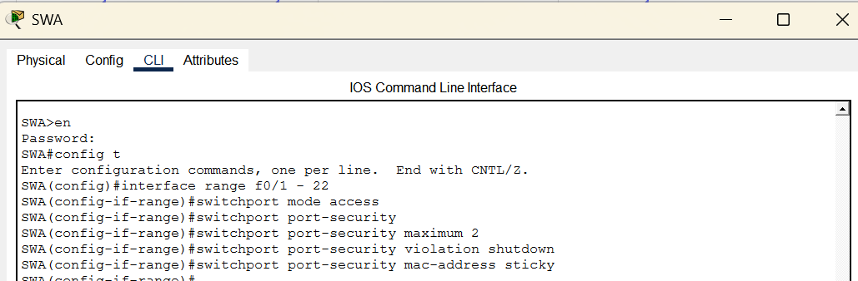

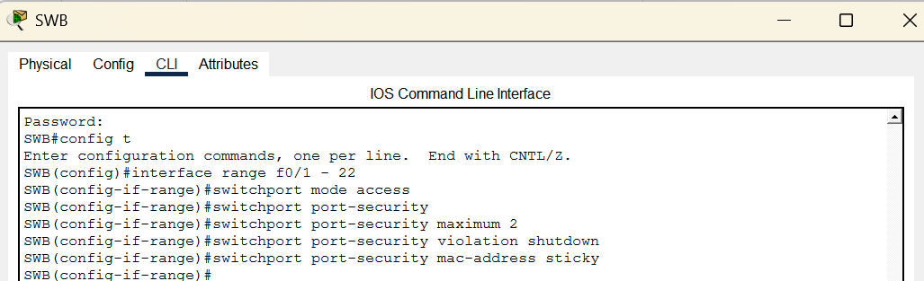

On SW-A, issue the command show port-security interface f0/1 to verify that port security has been Configured

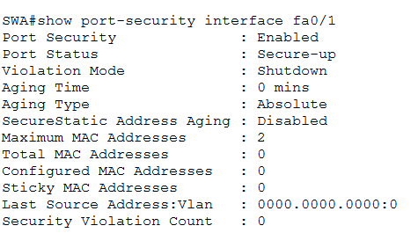

Disable all ports that are currently unused.
SWA(config)# interface range f0/5 - 22
SWA(config-if-range)# shutdown
SWB(config)# interface range f0/5 - 22
SWB(config-if-range)# shutdown

